**Probability Lab 5**

Anudit Nagar - E18CSE024

Question 1

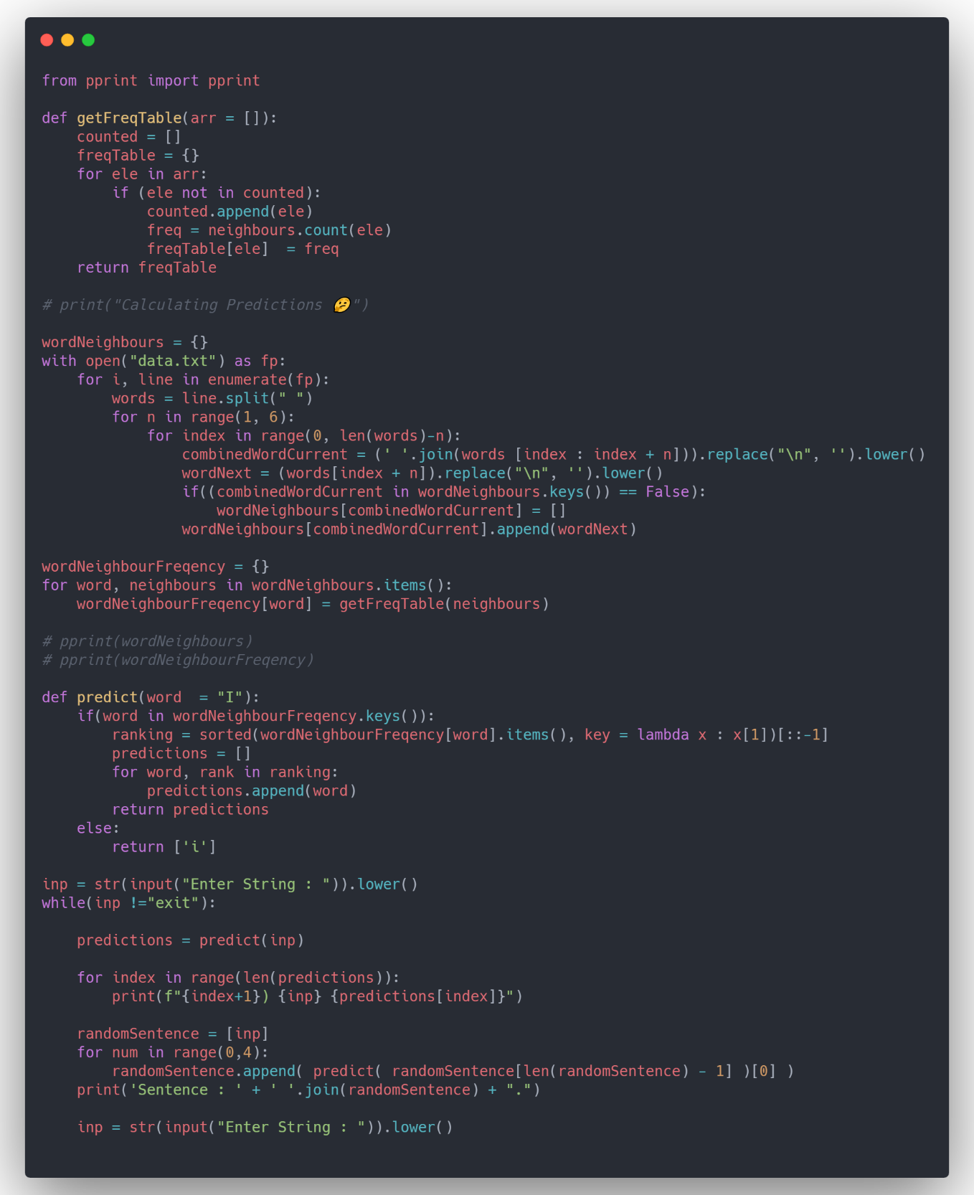 CODE

OUTPUT

Enter String : I

1) i love

2) i am

3) i will

4) i adore

5) i hate

6) i watch

7) i believe

Sentence : i love the way software.

Enter String : I love

1) i love the

2) i love my

3) i love and

4) i love doing

5) i love everything.

Sentence : i love the way software programs.

Enter String : I love the

1) i love the way

2) i love the beauty

3) i love the work

4) i love the world

Sentence : i love the way software programs work..

Enter String : exit